BEACH KINDER EMERGENCY EVACUATION POLICY

Quality Area 2

PURPOSE
This policy is a special circumstance policy which augments the RYE Pre School Emergency and Evacuation Policy and the Incident, Injury, Trauma & Illness Policy and should be read in conjunction with those policies. This Beach Kinder policy only details the specific evacuation procedures for children, staff and volunteers attending the Beach Kinder program in response to
an emergency or hazard that may arise during a session.
This policy aims to:
• Set out clear and safe evacuation principles and procedures for Bush Kinder participants
in response to an emergency situation of any type
• Increase awareness and implementation of emergency and evacuation procedures at
Beach Kinder amongst staff and the broader Pre School community
• Provide an appropriate mechanism for communication of the evacuation procedures for
requirements for Beach Kinder sessions to parents/guardians and to children.

POLICY STATEMENT 1. VALUES
Rye Pre School is committed to:
• Providing a safe environment for children, staff and volunteers participating in the Beach
Kinder program
• Ensuring that an appropriate response is provided, which meets the needs of participants
during and following emergency incidents
• Providing effective procedures in place to manage emergency incidents at the Beach Kinder site

2. SCOPE
This policy applies to children, parents/guardians, staff, committee members, authorised persons, volunteers and students on placement working at Rye Pre School.
3. BACKGROUND AND LEGISLATION Background
There are a multitude of possible emergency situations that may arise at Beach Kinder. These include, but are not limited to:
- • Fire / Bushfire
- • Chemical hazards
- • Missing child
- • Aggressive dogs off leads
- • Other animal intruders
- • Uninvited person/stranger (threatening, causing a nuisance or unease for staff & participants)
- • Toxic leak
- • Hostage/siege
- • Natural events, such as extreme weather, floods, severe winds, thunderstorm or earthquake
- • The involvement of firearms or other weapons
- • Hazardous substances incidents
- • Medical emergency (refer to Incident, Injury, Trauma and Illness policy)
- • Accident
The aim of this policy is to provide the appropriate response to such an incident or emergency to ensure the safety and wellbeing of all Beach Kinder participants.
© 2014 Early Learning Association Australia Bush Kinder Emergency Evacuation Policy (Version 1) Telephone 03 9489 3500 or 1300 730 119 (rural) Page 1 of 7
Legislation and standards
Relevant legislation includes but is not limited to:
- • Education and Care Services National Regulations 2011
- • Education and Care Services National Law 2010
- • National Quality Standard
- • Occupational Health and Safety Act 2004
- • Occupational Health and Safety Regulations 2007 4. DEFINITIONS
Assembly point: A predetermined and mapped safe place for the Beach Kinder group to meet after an emergency evacuation. [Refer to Attachment 1 for Beach Kinder assembly points]
Emergency: A sudden, unforeseen crisis (usually involving danger) that requires immediate action Emergency evacuation: Emergency evacuation is the immediate and rapid movement of
people away from the threat or actual occurrence of a hazard
Evacuation route: A predetermined and mapped safe route to move people away from a threat or danger. At Beach Kinder, the route taken will depend on the emergency/danger.
[Refer to Attachment 1 for Beach Kinder evacuation routes]
Hazard: The potential to harm a person’s health or safety that can arise from the environment, equipment and substances, poor work design and inappropriate practices and procedures
Notifiable incident: An incident involving workplace health and safety that is required by law to be reported to WorkSafe Victoria. Notification is required for incidents that result in death or serious injury/illness, or dangerous occurrences. For a complete list of incidents that must be reported to WorkSafe Victoria, refer to the Guide to Incident Notification on the WorkSafe Victoria website. This website also contains online reporting forms: www.worksafe.vic.gov.au
Serious incident: A serious incident is defined in Regulation 12 as:
• the death of a child while being educated and cared for by the service
• any incident involving an injury or trauma, or the illness of a child that requires or ought to
have required:
  - – attention of a registered medical practitioner, or
  - – attendance at a hospital
Examples include whooping cough, broken limb, anaphylaxis reaction
• any incident requiring attendance by emergency services
• a circumstance where a child appears to be missing, is unaccounted for, has been removed
from the service contrary to the Regulations, or has been locked in or out of the service premises.
The Approved Provider must notify the Regulatory Authority (DET) in writing within 24 hours of a serious incident occurring at the service (Regulation 176(2)(a)). The Notification of serious incident form (available on the ACECQA website) is to be completed and submitted online using the National Quality Agenda IT System (NQA ITS). Records are required to be retained for the periods specified in Regulation 183.
A serious incident must also be documented in an Incident, Injury, Trauma and Illness Record as soon as possible and within 24 hours of the incident.
© 2014 Early Learning Association Australia Bush Kinder Emergency Evacuation Policy (Version 1) Telephone 03 9489 3500 or 1300 730 119 (rural) Page 2 of 7

5. SOURCES AND RELATED POLICIES
Service policies
- • Excursions and Service events
- • Beach Kinder Delivery & Collection of Children Policy (Beach Kinder Specific)
- • Beach Kinder Extreme Weather Policy (Beach Kinder Specific)
- • Beach Kinder Safety and Hygiene Policy (Beach Kinder Specific)
- • Beach Kinder Protective Clothing Policy (Beach Kinder Specific)
- • Beach Kinder Snake Awareness Policy (Beach Kinder Specific)
- • Beach Kinder Dog Awareness Policy (Beach Kinder Specific)
- • Occupational Health & Safety
- • Incident, Illness, Trauma & Illness
- • Sun Protection
- • Water Safety
- • Supervision of Children
- • Child Safe Environment
PROCEDURES
The Committee of Management is responsible for:
- • Following all requirements in Rye Pre School’s main Emergency Evacuation Policy and the Incident, Injury, Trauma & Illness Policy
- • Establishing, monitoring and reviewing the Beach Kinder Risk Management Plan which identifies a number of potential hazards and risks and mechanisms for their treatment.
- • Establishing, monitoring and reviewing (in consultation with staff) emergency evacuation procedures, a series of safe evacuation routes and assembly points in response to a range of potential emergency situations [Refer to Attachment 1 for Beach Kinder evacuation procedures, routes and assembly points]
- • Ensuring emergency evacuation procedures are included in teachers’ documentation carried at Beach Kinder
- • Ensuring a fully equipped portable first aid kit is included with the Beach Kinder gear and equipment
- • Ensuring all teachers and volunteers are aware of the location of first-aid kit at Beach Kinder
- • Developing a regular training schedule for Bush Kinder staff that includes the operation of
communication systems, evacuation procedures, including evacuation routes and safe places;
and occupational health and safety and first aid
- • Ensuring that all children, staff, parents/guardians, students, volunteers and visitors
understand the requirements of this policy including conducting practice drills
- • Ensuring new Beach Kinder staff, students and volunteers have an understanding of the Beach
Kinder policy and procedures in relation to emergency evacuation in their induction procedure
- • Ensuring procedures are in place at Beach kinder to identify which staff are in attendance at any one time, such as the sign-in sheet. This can then be used to ensure that all staff are accounted
for in the event of an emergency.
© 2014 Early Learning Association Australia Bush Kinder Emergency Evacuation Policy (Version 1) Telephone 03 9489 3500 or 1300 730 119 (rural) Page 3 of 7

The Nominated Supervisor, Persons in Day-to-Day Charge and other educators are responsible for:
• Ensuring the safety of the children, fellow staff members and volunteers in their care and protecting them from hazards at Beach Kinder
• Being aware of the Beach Kinder evacuation procedures set out in this policy, along with the evacuation routes and assembly points in the different emergency scenarios as set out in Attachment 1.
• Conducting practice emergency evacuation procedures once each term, which are documented and dated
• Providing awareness and support to children before, during and after emergencies
• Providing input into the development of procedures to be followed in the event of an
emergency situation, and contributing to the review of the procedures following an emergency incident
• Informing the committee and reporting notifiable or serious incidents to the appropriate authorities
• Recording incidents in the incident book
• Ensuring that all children, staff and volunteers are accounted for in the event of an evacuation
Parents/guardians are responsible for:
• Reading and being familiar with the policy
• Bringing relevant issues to the attention of both staff and committee
• Ensuring children are signed in and out as per the requirements of the Pre School’s Delivery and Collection of Children Policy (both the main policy and the Beach Kinder Policy)
• Supporting children’s awareness and education in emergency situations
• Following the directions of staff during an emergency, incident or drill.
EVALUATION
In order to assess whether the policy has achieved the values and purposes the proprietor (committee) will:
- • Seek feedback regarding this policy and its implementation with parents of children participating in the Beach Kinder program. This can be facilitated through discussions and the annual centre survey.
- • Ask staff to share their experiences and observations in relation to the effectiveness of this policy.
- • Regularly review the policy and centre practices to ensure they are compliant with any new legislation, research or best practice procedures.
ATTACHMENTS
Attachment 1: Beach Kinder Evacuation Procedures, Assembly Points and Evacuation Routes
AUTHORISATION
This policy was adopted by the Rye Preschool committee of management on March 29th 2021 REVIEW DATE: March 2023 or as dictated by changes in regulations.
© 2014 Early Learning Association Australia Bush Kinder Emergency Evacuation Policy (Version 1) Telephone 03 9489 3500 or 1300 730 119 (rural) Page 4 of 7

Attachment 1
Beach Kinder Evacuation Procedures, Assembly Points and Evacuation Routes
Evacuation Procedures:
Whatever the emergency, incident or situation that necessitates the evacuation, the following procedures are to be followed by staff and volunteers
- Keep children calm
- Blow whistle three times
- Ensure sign-in sheet is in the teacher’s backpack along with other necessary items such as medication
- Count / check off against the sign in sheet to ensure all children are accounted for
- With the exception of the teacher’s backpack, leave Beach Kinder gear at the site – it can be collected later
- Assess the situation and determine where the closest safe zone assembly point is located
- En route to new location (see below for appropriate locations), calmly walk children in
pairs, keep group close together and ensure no child deviates from the group
- Teachers/adult volunteers to be positioned at the front and back of the group, and flanking the group where possible
- Notify emergency services if required
- On arrival at safe assembly point, conduct a full count/roll call to ensure all children are accounted for
- Notify parents of new location for collection (if required) via SMS from the Pre School’s mobile phone, parent response will be required to ensure all parents are aware
- Notify DET (if required)
- If the evacuation/relocation is for weather reasons, wait for the extreme weather to pass and when it does, resume normal activities if appropriate and safe to do so, following same relocation procedures to return to the Beach Kinder site
- If the weather does not look like it will pass soon, a broadcast SMS should be sent to all parents, advising of the new safe location for pickup purposes

Safe Zone Assembly Points and Routes
The safe zone assembly points will differ depending on the nature of the emergency and the location of the Beach Kinder site:
There are two possible Assembly points in the event that the group needs to see shelter from extreme weather.

BEACH KINDER | EVACUATION AND MEETING POINTS
MEETING/GATHERING POINT | LIME KILN/ BEACH KINDER SITE
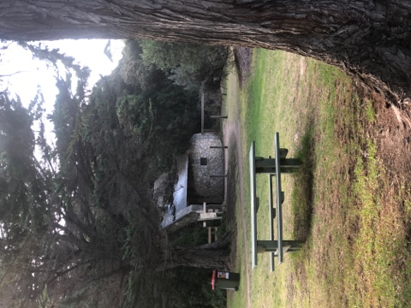 | *To be used to gather together entire group, head count, give instructions, evacuation decision point.
EVACUATION POINT A | T114 TOILET BLOCK
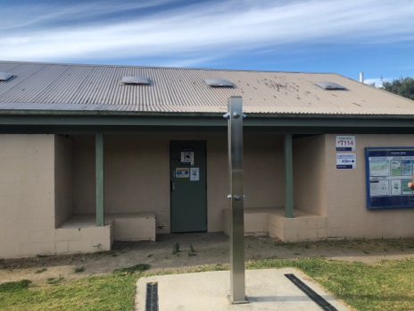 | *Close by onsite evacuations.  *Sudden conditions.  -Torrential rain,  - Hail,  - Electrical storm,  -Extreme winds
EVACUATION POINT B | LIONS BEACH SHELTER  RYE FORESHORE
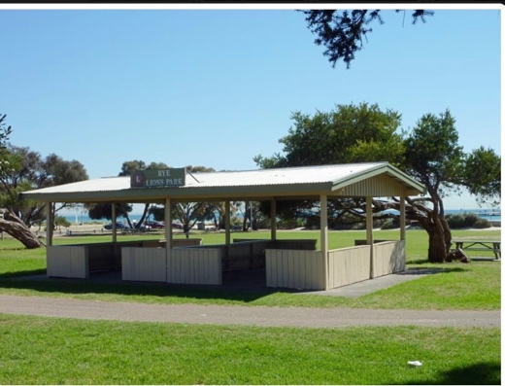 | *Further distance evacuations  *Situations at site that require further distance away.  -Fire  -Aggressive dog off lead  -Toxic leak/Chemical danger
FULL EVACUATION | *Return to Rye Pre-School home base.

